NAMA : MARSHAURA AISYAHLA ZAHRAN

NIM : 40011423650273

KELAS : G_AKUNTANSI PERPAJAKAN

MATERI PEMMBELAJARAN 6 DESEMBER 2024

Pada pertemuan kali ini kita membuat Bigquerry menggunakan data kita sendiri, berhubung data saya yang kemarin tidak bisa di run saya mencari data baru yaitu sebagai berikut :

**Data Produksi**

|  |  |  |  |  |
| --- | --- | --- | --- | --- |
| **ProduksiID** | **TanggalProduksi** | **ProdukID** | **JumlahProduksi** | **BiayaProduksi** |
| 1,00 | 2023-07-03 | 4,00 | 151,00 | 162339,92 |
| 2,00 | 2023-11-12 | 2,00 | 184,00 | 85422,72 |
| 3,00 | 2023-06-05 | 8,00 | 139,00 | 53725,35 |
| 4,00 | 2023-07-08 | 9,00 | 93,00 | 104260,18 |
| 5,00 | 2023-02-28 | 6,00 | 88,00 | 194931,99 |
| 6,00 | 2023-12-07 | 3,00 | 193,00 | 195329,16 |
| 7,00 | 2023-05-11 | 10,00 | 168,00 | 100238,14 |
| 8,00 | 2023-04-06 | 9,00 | 65,00 | 121499,23 |
| 9,00 | 2023-05-14 | 1,00 | 163,00 | 155214,29 |
| 10,00 | 2023-07-27 | 8,00 | 60,00 | 118376,14 |
| 11,00 | 2023-04-21 | 8,00 | 160,00 | 114880,23 |
| 12,00 | 2023-01-22 | 7,00 | 67,00 | 183071,86 |
| 13,00 | 2023-06-20 | 9,00 | 139,00 | 162563,41 |
| 14,00 | 2023-02-10 | 3,00 | 125,00 | 67836,93 |
| 15,00 | 2023-08-03 | 4,00 | 65,00 | 52679,98 |
| 16,00 | 2023-11-05 | 8,00 | 73,00 | 97951,18 |
| 17,00 | 2023-05-23 | 9,00 | 177,00 | 135868,47 |
| 18,00 | 2023-08-13 | 1,00 | 63,00 | 131567,97 |
| 19,00 | 2023-09-24 | 1,00 | 50,00 | 93258,25 |
| 20,00 | 2023-07-27 | 10,00 | 93,00 | 100319,73 |

**Data Penjualan**

|  |  |  |  |  |  |
| --- | --- | --- | --- | --- | --- |
| **PenjualanID** | **TanggalPenjualan** | **ProdukID** | **JumlahTerjual** | **HargaJual** | **TotalPenjualan** |
| **1,00** | **2023-07-14** | **1,00** | **29,00** | **162111,02** | **584950,45** |
| **2,00** | **2023-12-01** | **7,00** | **17,00** | **481298,86** | **606272,23** |
| **3,00** | **2023-08-25** | **5,00** | **37,00** | **421847,14** | **746526,65** |
| **4,00** | **2023-07-27** | **6,00** | **40,00** | **470022,32** | **817775,23** |
| **5,00** | **2023-07-24** | **6,00** | **9,00** | **243203,85** | **1074207,59** |
| **6,00** | **2023-06-09** | **9,00** | **31,00** | **169662,33** | **1865312,94** |
| **7,00** | **2023-01-02** | **6,00** | **40,00** | **158705,81** | **993876,73** |
| **8,00** | **2023-06-28** | **2,00** | **39,00** | **269908,33** | **927585,95** |
| **9,00** | **2023-12-03** | **9,00** | **15,00** | **250929,40** | **554368,43** |
| **10,00** | **2023-12-15** | **7,00** | **16,00** | **447991,09** | **1991200,23** |
| **11,00** | **2023-07-09** | **10,00** | **39,00** | **155512,79** | **579949,65** |
| **12,00** | **2023-12-26** | **9,00** | **44,00** | **246640,36** | **1148506,18** |
| **13,00** | **2023-12-02** | **1,00** | **47,00** | **375639,32** | **563243,17** |
| **14,00** | **2023-08-28** | **9,00** | **34,00** | **344733,65** | **1790390,68** |
| **15,00** | **2023-01-27** | **2,00** | **32,00** | **302610,27** | **904880,62** |
| **16,00** | **2023-08-30** | **4,00** | **25,00** | **175810,57** | **1120558,10** |
| **17,00** | **2023-10-03** | **10,00** | **6,00** | **354727,41** | **1043009,76** |
| **18,00** | **2023-08-25** | **8,00** | **22,00** | **156898,51** | **1705976,95** |
| **19,00** | **2023-11-26** | **6,00** | **14,00** | **315722,37** | **1742760,99** |
| **20,00** | **2023-06-17** | **4,00** | **21,00** | **389840,48** | **599343,33** |

**Data Persediaan**

|  |  |  |  |
| --- | --- | --- | --- |
| **PersediaanID** | **ProdukID** | **TanggalUpdate** | **JumlahStok** |
| 1,00 | 5,00 | 2023-03-31 | 125,00 |
| 2,00 | 3,00 | 2023-03-13 | 115,00 |
| 3,00 | 8,00 | 2023-06-16 | 66,00 |
| 4,00 | 2,00 | 2023-06-28 | 31,00 |
| 5,00 | 3,00 | 2023-06-01 | 150,00 |
| 6,00 | 5,00 | 2023-02-11 | 74,00 |
| 7,00 | 4,00 | 2023-02-09 | 69,00 |
| 8,00 | 2,00 | 2023-11-11 | 133,00 |
| 9,00 | 3,00 | 2023-12-26 | 99,00 |
| 10,00 | 4,00 | 2023-01-03 | 88,00 |
| 11,00 | 7,00 | 2023-01-07 | 61,00 |
| 12,00 | 1,00 | 2023-02-07 | 72,00 |
| 13,00 | 5,00 | 2023-09-28 | 50,00 |
| 14,00 | 10,00 | 2023-02-15 | 84,00 |
| 15,00 | 8,00 | 2023-03-14 | 110,00 |
| 16,00 | 8,00 | 2023-06-05 | 79,00 |
| 17,00 | 2,00 | 2023-02-12 | 107,00 |
| 18,00 | 7,00 | 2023-12-06 | 143,00 |
| 19,00 | 5,00 | 2023-06-06 | 134,00 |
| 20,00 | 7,00 | 2023-04-19 | 95,00 |

Setelah mencari data selanjutnya kita rubah dalam bentuk CSV to Excel

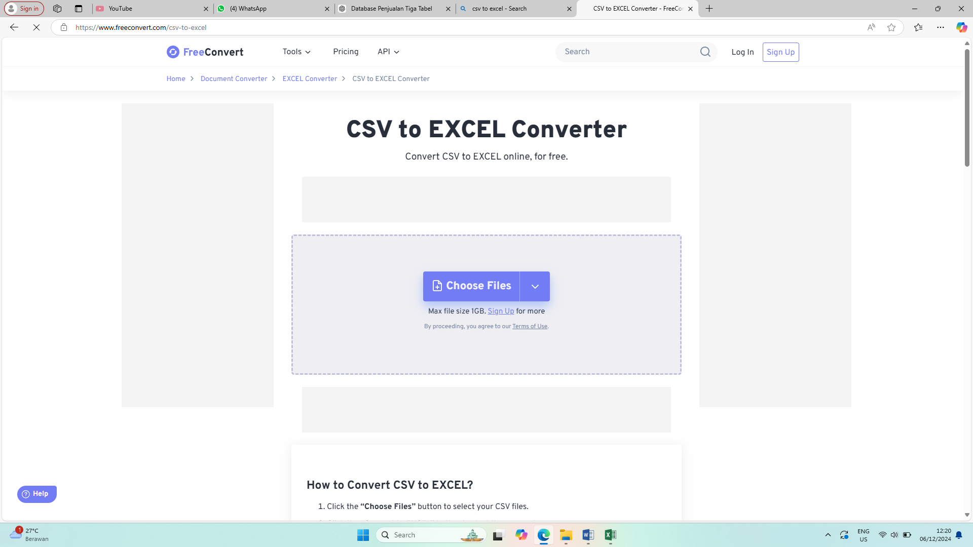

**DIATAS MERUPAKAN CSV YANG SAYA GUNAKAN**

Selanjutnya masukan ketiga data tersebut ke dalam CSV

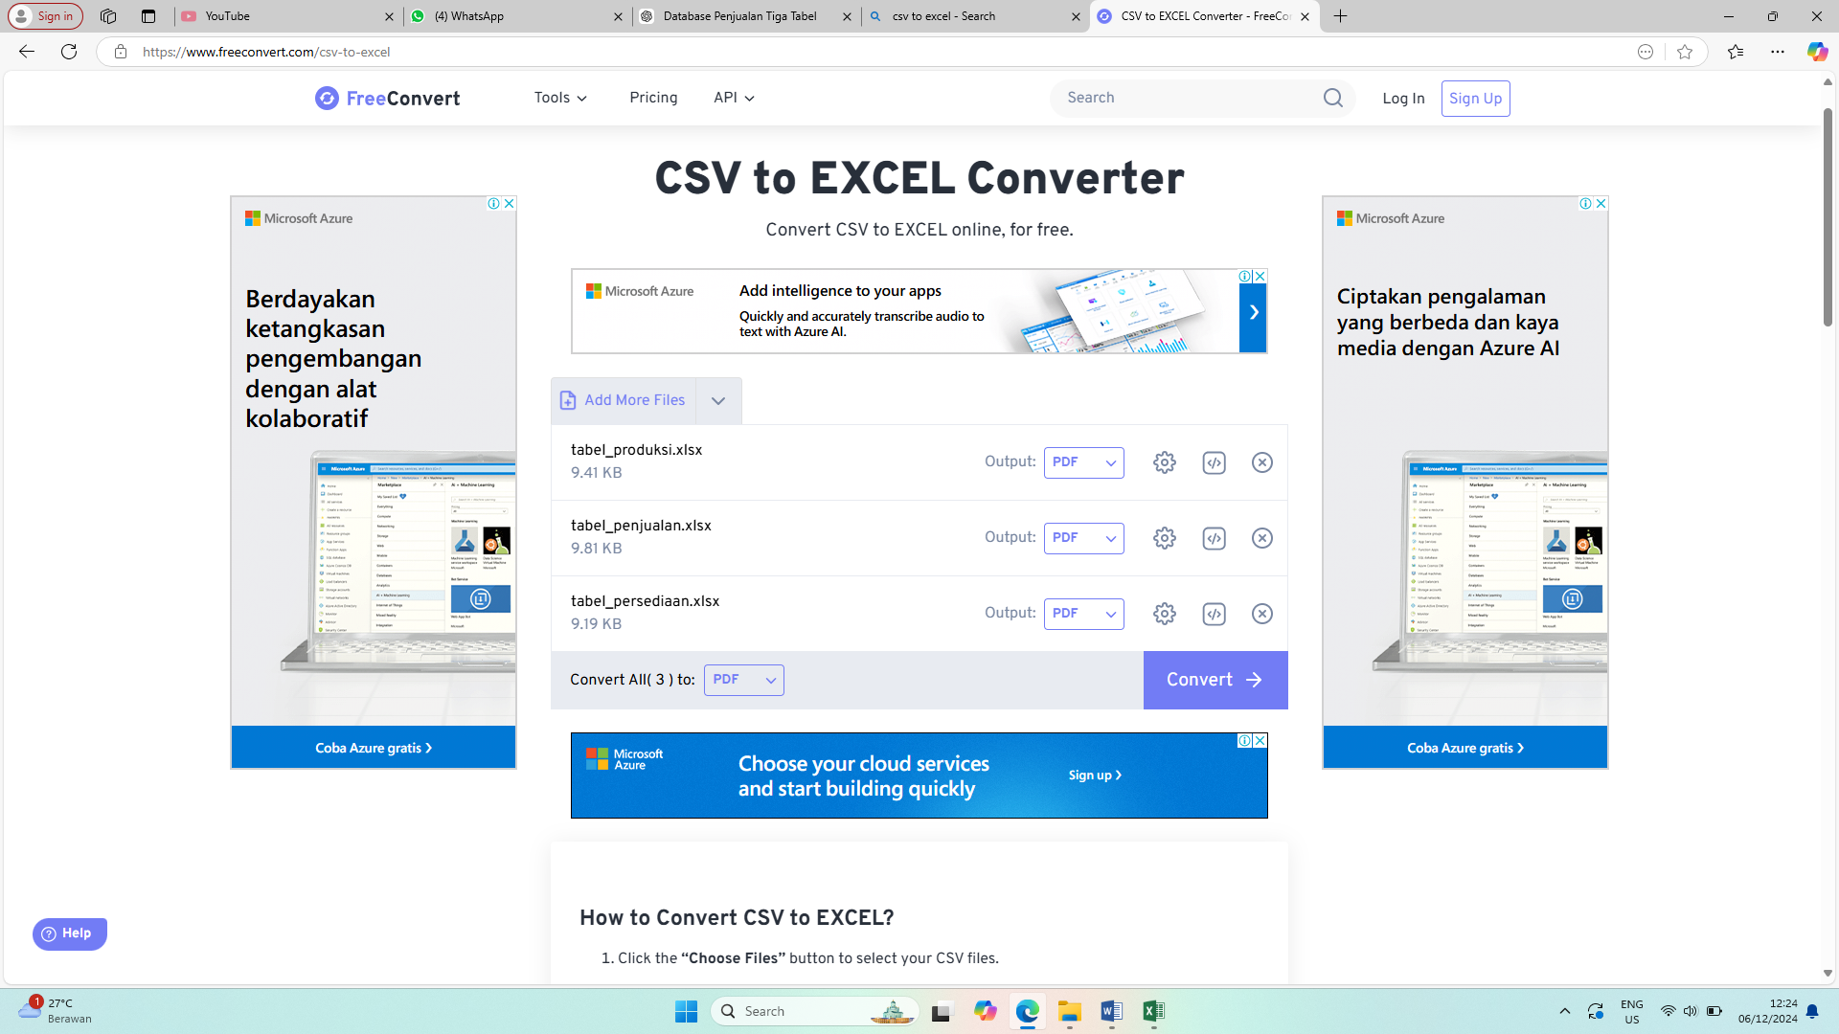

Berikut data yang setelah di CSV

**Data Produksi**

|  |  |  |  |
| --- | --- | --- | --- |
| ProduksiID,"TanggalProduksi","ProdukID","JumlahProduksi","BiayaProduksi","" | | | |
| 1.00,"2023-07-03","4.00","151.00","162339.92","" | | | |
| 2.00,"2023-11-12","2.00","184.00","85422.72","" | | | |
| 3.00,"2023-06-05","8.00","139.00","53725.35","" | | | |
| 4.00,"2023-07-08","9.00","93.00","104260.18","" | | | |
| 5.00,"2023-02-28","6.00","88.00","194931.99","" | | | |
| 6.00,"2023-12-07","3.00","193.00","195329.16","" | | | |
| 7.00,"2023-05-11","10.00","168.00","100238.14","" | | | |
| 8.00,"2023-04-06","9.00","65.00","121499.23","" | | | |
| 9.00,"2023-05-14","1.00","163.00","155214.29","" | | | |
| 10.00,"2023-07-27","8.00","60.00","118376.14","" | | | |
| 11.00,"2023-04-21","8.00","160.00","114880.23","" | | | |
| 12.00,"2023-01-22","7.00","67.00","183071.86","" | | | |
| 13.00,"2023-06-20","9.00","139.00","162563.41","" | | | |
| 14.00,"2023-02-10","3.00","125.00","67836.93","" | | | |
| 15.00,"2023-08-03","4.00","65.00","52679.98","" | | | |
| 16.00,"2023-11-05","8.00","73.00","97951.18","" | | | |
| 17.00,"2023-05-23","9.00","177.00","135868.47","" | | | |
| 18.00,"2023-08-13","1.00","63.00","131567.97","" | | | |
| 19.00,"2023-09-24","1.00","50.00","93258.25","" | | | |
| 20.00,"2023-07-27","10.00","93.00","100319.73","" | | | |
| ,"","","","","" |  |  |  |

**Data Penjualan**

|  |  |  |  |  |
| --- | --- | --- | --- | --- |
| PenjualanID,"TanggalPenjualan","ProdukID","JumlahTerjual","HargaJual","TotalPenjualan","","" | | | | |
| 1.00,"2023-07-14","1.00","29.00","162111.02","584950.45","","" | | | | |
| 2.00,"2023-12-01","7.00","17.00","481298.86","606272.23","","" | | | | |
| 3.00,"2023-08-25","5.00","37.00","421847.14","746526.65","","" | | | | |
| 4.00,"2023-07-27","6.00","40.00","470022.32","817775.23","","" | | | | |
| 5.00,"2023-07-24","6.00","9.00","243203.85","1074207.59","","" | | | | |
| 6.00,"2023-06-09","9.00","31.00","169662.33","1865312.94","","" | | | | |
| 7.00,"2023-01-02","6.00","40.00","158705.81","993876.73","","" | | | | |
| 8.00,"2023-06-28","2.00","39.00","269908.33","927585.95","","" | | | | |
| 9.00,"2023-12-03","9.00","15.00","250929.40","554368.43","","" | | | | |
| 10.00,"2023-12-15","7.00","16.00","447991.09","1991200.23","","" | | | | |
| 11.00,"2023-07-09","10.00","39.00","155512.79","579949.65","","" | | | | |
| 12.00,"2023-12-26","9.00","44.00","246640.36","1148506.18","","" | | | | |
| 13.00,"2023-12-02","1.00","47.00","375639.32","563243.17","","" | | | | |
| 14.00,"2023-08-28","9.00","34.00","344733.65","1790390.68","","" | | | | |
| 15.00,"2023-01-27","2.00","32.00","302610.27","904880.62","","" | | | | |
| 16.00,"2023-08-30","4.00","25.00","175810.57","1120558.10","","" | | | | |
| 17.00,"2023-10-03","10.00","6.00","354727.41","1043009.76","","" | | | | |
| 18.00,"2023-08-25","8.00","22.00","156898.51","1705976.95","","" | | | | |
| 19.00,"2023-11-26","6.00","14.00","315722.37","1742760.99","","" | | | | |
| 20.00,"2023-06-17","4.00","21.00","389840.48","599343.33","","" | | | | |
| ,"","","","","","","" |  |  |  |  |

**Data Persediaan**

|  |  |  |
| --- | --- | --- |
| PersediaanID,"ProdukID","TanggalUpdate","JumlahStok","" | | |
| 1.00,"5.00","2023-03-31","125.00","" | | |
| 2.00,"3.00","2023-03-13","115.00","" | | |
| 3.00,"8.00","2023-06-16","66.00","" | | |
| 4.00,"2.00","2023-06-28","31.00","" | | |
| 5.00,"3.00","2023-06-01","150.00","" | | |
| 6.00,"5.00","2023-02-11","74.00","" | | |
| 7.00,"4.00","2023-02-09","69.00","" | | |
| 8.00,"2.00","2023-11-11","133.00","" | | |
| 9.00,"3.00","2023-12-26","99.00","" | | |
| 10.00,"4.00","2023-01-03","88.00","" | | |
| 11.00,"7.00","2023-01-07","61.00","" | | |
| 12.00,"1.00","2023-02-07","72.00","" | | |
| 13.00,"5.00","2023-09-28","50.00","" | | |
| 14.00,"10.00","2023-02-15","84.00","" | | |
| 15.00,"8.00","2023-03-14","110.00","" | | |
| 16.00,"8.00","2023-06-05","79.00","" | | |
| 17.00,"2.00","2023-02-12","107.00","" | | |
| 18.00,"7.00","2023-12-06","143.00","" | | |
| 19.00,"5.00","2023-06-06","134.00","" | | |
| 20.00,"7.00","2023-04-19","95.00","" | | |
| ,"","","","" |  |  |

**Setelah di rubah ke CSV selanjutnya kita membuat soal sendiri, berikut adalah soal saya**

bantu saya

Saya sedang menggunakan BigQuery untuk menganalisis data penjualan dan produksi

produk dari dua tabel yang telah saya unggah, yaitu tabel_produksi dan tabel_penjualan,

yang ada dalam dataset perusahaan di project saya bernama marshaura-aisyahla-zahran.company_marsha Saya ingin

mencari id_produk dengan jumlah penjualan tertinggi selama 6 bulan pertama tahun

2024, yaitu dari tanggal 1 Januari hingga 30 Juni 2024. Kriteria lainnya adalah

id_produksi nya bernomor genap.

Catatan untuk membantu anda mengerjakan:

• Kolom id_produk, id_produksi, dan tanggal produksi ada di tabel_produksi,

• Kolom jumlah_terjual ada di tabel_penjualan

• Untuk cari penjualan terbesar: jumlah_terjual nya bisa diurutkan saja dari yang

terbesar ke terkecil

• Kolom yang dipakai hanya id_produk, id_produksi, tanggal_produksi, dan jumlah

terjual saja

• Untuk menghubungkan 2 tabel tersebut menggunakan foreign key, foreign key

nya yaitu kolom id_produk

Dapatkah Anda memberikan query SQL khusus BigQuery untuk menjalankan analisis ini?

**Setelah membuat soal kita membuat SQL menggunakan blackbox menghasilan SQL sebagai berikut**

SELECT

p.ProdukID,

pr.ProduksiID,

pr.TanggalProduksi,

SUM(p.JumlahTerjual) AS TotalTerjual

FROM

marshaura-aisyahla-zahran.company_marsha.tabel_penjualan p

JOIN

marshaura-aisyahla-zahran.company_marsha.tabel_produksi pr

ON

p.ProdukID = pr.ProdukID

GROUP BY

p.ProdukID, pr.ProduksiID, pr.TanggalProduksi

LIMIT 10;

**Setelah bikin soal kemudian kita masuk ke dalam bigquerry menggunakan link di bawah ini**

<https://console.cloud.google.com/bigquery?sq=632956686318:3bf27d149d8f4f01a94c9a5553260137>

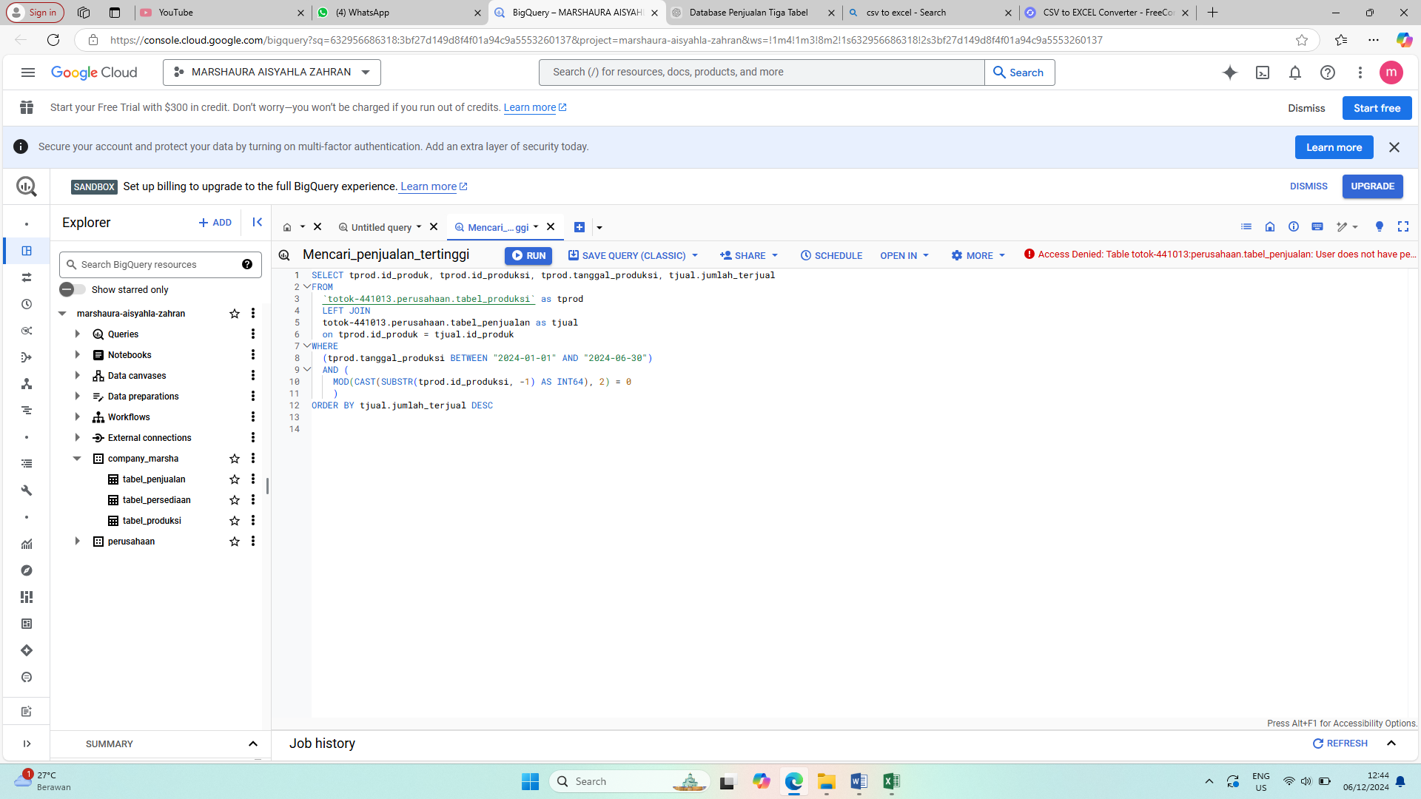

**Setelah itu masukan SQL nya kedalam bigquerry**

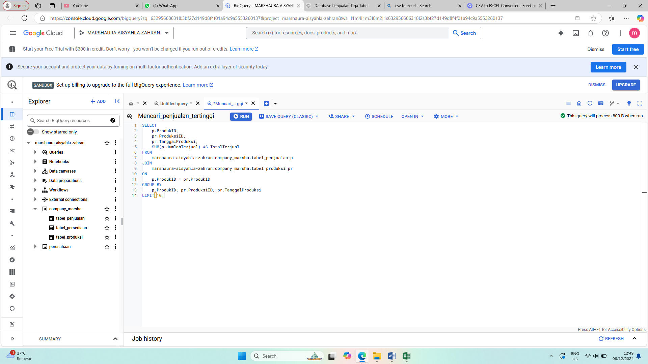

**Setelah itu kita run**

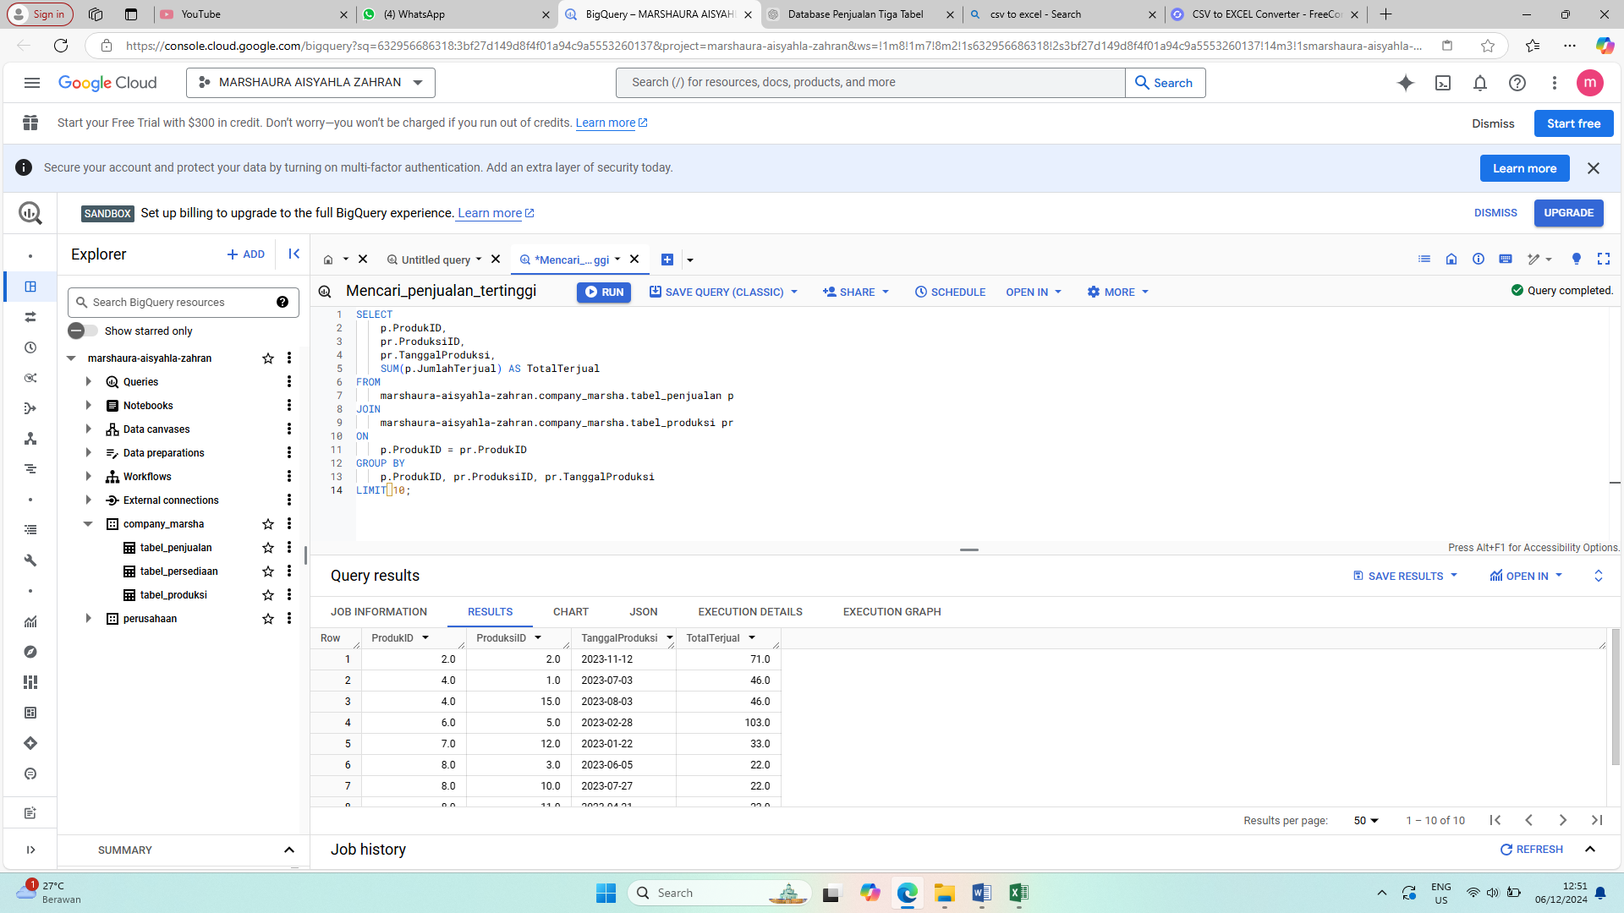

**Berikut adalah hasil bigquerry yang saya buat**

